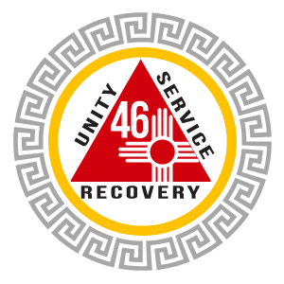 ARCHIVES

AREA 46 – NEW MEXICO

**GROUP HISTORY FORM**

Prepared by:  District: Group #:

Name of Group:

Previous Name:

Location:

Date Founded:

Present membership Number:

Answer the questions of page 2-3, using page 1 as a cover letter.

Submit to: [archivist@nm-aa.org](mailto:archivist@nm-aa.org) and [archiveschair@nm-aa.org](mailto:archiveschair@nm-aa.org)

AREA 46 ARCHIVES GROUP HISTORY FORM – Page 2

Who were the founding members of the group?

Where and when was the first meeting held? In date order, list where later meetings have been held.

Did the group list with the General Service Office at the time the members first met?

What is the group’s name? Have there been any changes to the group’s name?

What initiated the meeting: was it the offshoot of a parent group; was there a split due to disagreements; did a few AAs simply decide to start a hometown group?

How did the founding members let the community know that a new AA meeting was forming?

How many members attended the group’s first meeting?

Describe member composition, i.e., men only, women only, young people, etc.

How did the group experience growth of the years?

Are group inventories conducted regularly? If so, have they been helpful?

Who were the early group officers (GSR, Chair, Secretary, etc.)?

Have any group members participated in District, Area, or other service to the Fellowship?

AREA 46 ARCHIVES GROUP HISTORY FORM – Page 3

How often were meetings held and has that changed over the years?

What meeting formats have been used (closed, open, discussion, speaker, etc.)?

Describe the group’s growing pains or controversies.

How does the group celebrate group member’s anniversaries of sobriety?

How has the group celebrated the anniversary of its’ founding?

Has your group had any special occasions or events that were memorable?

Have you had members of your group pass away to the big meeting in the sky?

Describe how the group has cooperated with professional agencies (by signing court cards, supporting a meeting in an institutional setting, taking regular phone duty at the Intergroup or Central Office, etc.).

Has the group participated in special local or regional AA functions, such as conventions, conferences, area assemblies, round-ups, forums, or workshops?

Please include any other information that relates to the history of your group.

Special questions related to the pandemic:

Have you been able to preserve the AA fellowship outside of the in-person rooms? If so, how?

Does your group plan to continue with online meetings or an online component after this is over?

Describe any new creative ways you’ve found to do 12-step / service work.

Have you or your groups taken steps to stay connected with more at-risk AA members (older and/or dealing with health issues) and tech challenged AAs?

How do we implement the responsibility statement and ensure that the hand of AA will always be there?