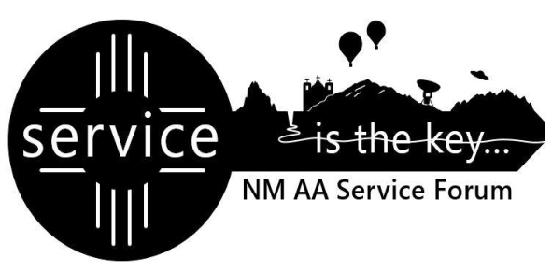

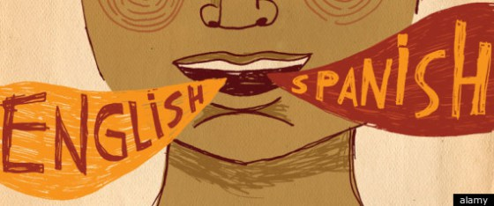

**The entire AA community is invited to**

**attend a WORKSHOP**

**DATE: Saturday 28 of January, 2023**

**PLACE: Grupo Tres Legados**

**5509 Central Ave NW Plaza West #5**

**TIME: 7 PM to 8:30 PM**

**We will have the participation of**

* **Alejandro V.: Grupo El Perdon with the topic:**

**What is a Forum**

* **Ana G.: Grupo Tercera Tradición with the topic:**

**Functions and Responsibilities of a G.S.R.**

* **Area 46 Delegate: Eloy M. with the topic:**

**Inclusivity**

**A DELICIOUS PLATE WILL BE SERVED**